A SIMPLE, EASY, FUN WAY OF WRITING A BUSINESS PLAN!
Since 1980 I have had to write about 25 different business plans for various businesses that I was starting or had already started. Each time I had to write a plan I dreaded the experience because the process was so time consuming, boring, and complex. As a teacher of business planning it has been my goal for over nine years to create a simpler, easy to understand, and fun way to create a business plan.

From my experiences of writing plans and presenting them over 300 times to investors looking for money, I learned two things:
- Plans do not get read because they are usually too long, too boring, too complex, and do not tell the real “story” behind the business.
- People don’t give loans or invest in businesses from Business Plans; they make buying decisions from the Question and Answer period before, during after an investor presentation.

So if the “buy in” to a new businesses happens during the question and answer period, why not make the business plan simply the answers to the questions? This is exactly what the 21 Question Business Plan is! The questions in the 21 Question Business Plan are the questions bankers and investors are going to ask anyway! All you have to do is answer 21 questions and you have competed 90% of your plan (you will still need to provide at least 12 months of financials, but even most of that is included in the 21 Questions).

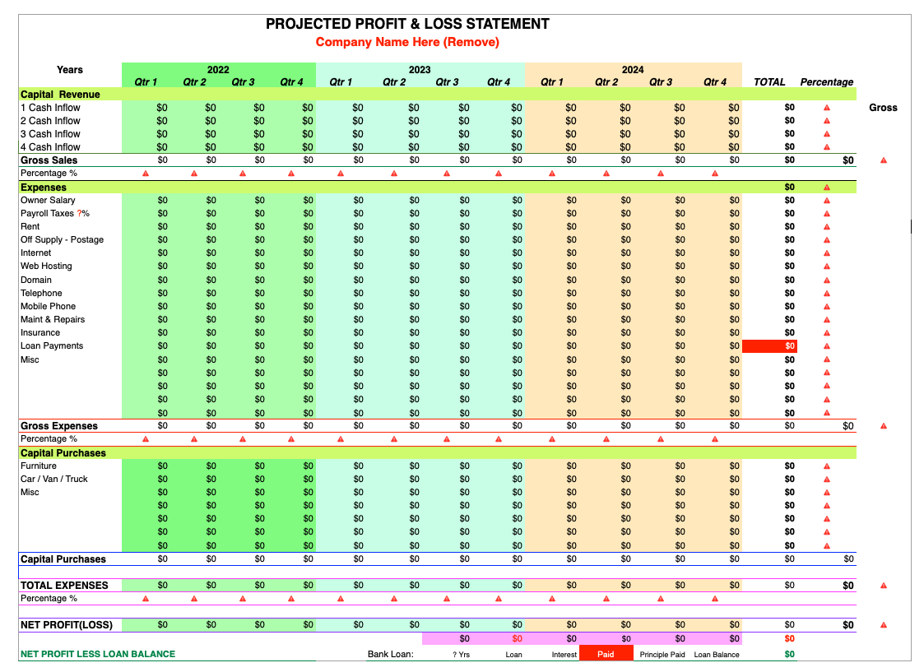
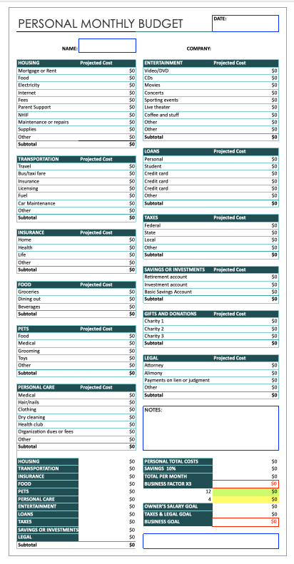
I have taken the 21 Questions Business Plan format and presented it to a Bank President and a number of investors. I asked them, “If you got a business plan that was laid out as 21 questions and 21 answers, what would you think of the plan?” Universally they stated how simple the concept is and how easy it is to get a grasp of the idea and the business! The 21 Question Business Plan is now used in all my classes on business planning, both in the classroom and online.

All Financial numbers should be done on Xcel or Numbers (Apple) Spread sheets that you attach to this document.

WANT TO MAKE BUSINESS PLANNING SIMPLE…
JUST ANSWER
21 QUESTIONS!
CREATING A BRILLIANT BUSINESS PLAN
Answer to the best of your ability all questions.
Then REMOVE ALL RED COPY.

21 QUESTIONS ABOUT
Name of your Company?

PART 1: YOU AND YOUR BUSINESS IDEA
- How would you describe your business idea?
YOUR ANSWER HERE:
What you are really creating here is a “description of the business”. Use your imagination and create a 1-2 page document that describes in detail the business as it exists in your mind. Where will it be located, who will do what, how much money will you make, who are your customers? All these questions can be answered in the description. This should be a “brain-dump” with your best guesses at this point. After reading this answer the reader should have a clear understanding of what this business is and what your dream for this business is. Also by answering this question, the reader should know what makes this business unique and different from everyone else. Reading the answer to this question needs to also tell how people purchase your products or services. Start with the Business Model sheet to verify the business can meet your financial goals!

- Why are you starting this business?
YOUR ANSWER HERE:
By answering this question you are giving the REAL reason why you are starting this particular business. Are you doing this business because it is the only thing you know; is this your passion; or do you have experience doing this? What are the reasons? After reading the answer to this question, the reader should know why you chose this business over another one. Also reading this answer should allow the reader to gather some insights on your background and why you have now decided that this is the right time to get your new business idea going.

- Why are you the right person to start, run and own this business?
YOUR ANSWER HERE:
This answer is all about you personally. Much of this is about your experience, your knowledge base and your job history. Have you ever started and run a business before? Do you have experience in the industry your business is in? Does your job history say you can do it? What in your past would prove to someone that you are right person to do this? In addition, your education (both formal and informal) is very important and gives the reader a comfort level that you can get this business off the ground and make it successful. After reading this, the reader should gain a high degree of confidence that you are the right person for this business and that you can make it happen!

- How is your business organized?
YOUR ANSWER HERE:
This question needs to have two parts to the answer. The first part is about the legal structure of your business and the second part is about who does what in your business. In the first part you will need to identify what type of business entity you have chosen and why you chose the entity you did. Are you a sole proprietor, “S” Corp, or an LLC? Each type of entity has its own pluses and minuses so some justification as to why you selected the entity that you did is important. In the second part you might include on organizational (org) chart for the business or simply highlight all the things that need to be done in the business and tell who does what. Some key parts here is who does the sales and marketing, who is watching the money, and how makes the decisions for the business. After reading this answer the reader should know that you have thought through the legal issues of the business and defined the job responsibilities for the entire business.

- What goals do you want to accomplish in the first 12 months of your business?
YOUR ANSWER HERE:
The first 12 months of the business are the most critical for new business owners. More businesses fail in the first 12 months of operation than in any other time period. One of the best ways of making sure your business does not become a failure statistic is to have a set of specific and measurable goals for the business to achieve in the first 12 months of operation. The best way of setting goals is to start with the end in mind. What needs to happen in the first 12 months of operation for the business to gain traction and momentum and for you as the business owner (bizowner) to feel satisfied with your efforts? For the first 12 months you should have a sales goal, a quantity and quality of customer goal, and a profit goal. In order for the goals to be real they must be able to be broken down into smaller time units like months or quarters, so they can be easily worked on. After reading the answer to this question the reader should have a clear understanding of what needs to be accomplished in the first 12 months of your business. Many business plans want as much as five years of projections and goals. Because business is moving at such a fast pace and because so many businesses fail in the first 12 months, just keep you goals to the first year. Your first and most important goal for any new business is not to just survive the first year, but to gain enough momentum to establish a solid foundation for your business to grow on for the years to come.

PART 2: RESEARCH, COMPETITION AND COMPETITIVE ADVANTAGES

- Why is this business a good business to start?
YOUR ANSWER HERE:
In this question you are answering the question with research. For example, are the trends in the industry you are in growing, flat or decreasing? Are more or less dollars being spent on your product or service? Answer this question from the standpoint of someone who knows nothing about what you are doing. Your answer to this question proves to the reader that this business really has a strong chance of success. You should also address the issue of time. Are you starting this business immediately or sometime in the future? In either case, you also need to answer why now, or later, would be the best time to start this business. Most readers like to see visuals and data. Charts, graphs and data that support your research that this is a good business to start are important as you answer this question. When it comes to research, more is better than less. Summarizing the data into 3-5 bullet points is also much appreciated by people who read business plans.

- Who is your competition?
YOUR ANSWER HERE:
Every business has competition, and competition is getting tougher and smarter all the time. By answering this question you are identifying who the competition is for the business you want to start. One way of thinking about this question is to identify your target customer. Suppose you are opening up a Handyman business. You first question is how far are you willing to go to do a job. Set the max diving distance and identify all the handymen within that area that compete with you. If you are an internet business, then you competitors could come from anywhere. Once you have named the competitors, also tell what you know about each competitor. What makes these competitors strong and unique? What makes them special? People who read business plans are looking very hard at this section to make sure you have a clear understanding of the competitive obstacles you are going to face as you launch your business.

- What are your competitive advantages?
YOUR ANSWER HERE:
All the questions are important, but this one really stands out. Competitive advantages are defined as things or attributes of your business that make it different, better, or a better value than your competition. One of the best ways of understanding competitive advantages is to look at the business of selling sub sandwiches. Subway® owned the sub business until an upstart called Quiznos® entered the market. Initially Quiznos® had one big competitive advantage, they toasted their subs. For a period of time Quiznos® took a lot of business from Subway® with that one competitive advantage. Once Subway® put ovens in their stores the competitive advantage went away, and so did a lot of Quiznos® profitability! If you do not have competitive advantages over your competition, then you would be considered a commodity and everything is then based on price alone! Try and list at least a few competitive advantages that you have over your competition! When you watch ads on television you get a clear idea of the competitive advantages one product or service has over another. Think in terms of an ad, what do you want your potential customer to remember about your product or service. From an investor standpoint, they want some clear competitive advantages if they are going to invest in your business.

Part 3: SALES, PRICES AND MARGINS

- What do you charge for your products or services?
YOUR ANSWER HERE:
Like questions #7 AND #8, this is also a major question that needs to be answered. It might sound simple but it should require a lot of thought. Most new business owners price too low. If there is one universal issue that most small business owner have, it is that they charge too little for their products or services. It is always best to start high and then if you need be come down, you can. The easiest way to answer this question is to know what a “typical” sale is, and what you are going to charge for a typical sale. Answering this question is the first step to building projections and being able to see if you can make a living by doing your business. A good way of answering this question is to include a price list.

- What is the reasoning behind your prices?
YOUR ANSWER HERE:
In Question #9 you identified how much you will charge for your products or services. In this question I want to know why you are pricing your products or services the way you are. What is the justification behind your prices? If you are lower, higher, or the same as the competition, explain why you chose the pricing that you did. Do you know everything that goes into your prices, and is that part of your pricing policy? Some businesses have a pricing policy that their prices are absolute and firm and they will not deviate. Other businesses set prices with room to negotiate if they need to. Remember, if you have competitive advantages, then you have clear justification to have higher prices!

- How much do you make on what you sell?
YOUR ANSWER HERE:
In this question we are dealing with what is called either “gross profit” or “gross margin”. They both mean the same thing. This is done by taking your selling price and subtracting your cost of goods (COGS). The formula is as follows:

Selling price – costs of goods = Gross margin or gross profit

If you are running a consulting business and are charging $100 an hour for example then your gross margin would be $100 since there are no costs coming out of the $100. If you are selling lamps for $59.95 and it costs you $20.00 to make each lamp (COGS), then your gross margin is $59.95 minus $20.00 or $39.95. Gross margin percentage is another important number you need to be comfortable with. To figure out gross margin percentages take the gross margin and divide it by the selling price. The formula looks like this:

Gross margin / Selling price = gross margin percentage

In the lamp example dividing $39.95 (gross margin) by $59.95 (selling price) you have a gross margin percentage of 67%. In the case of the consultant above, because there is no cost of goods sold (COGS), the consultant has a 100% gross margin percentage. Both the gross margin and the gross margin percentage are critical “need to knows” as you begin to put together financials and understand what it is going to take to get your business to profitability

- What do you estimate your first year sales will be by month?
YOUR ANSWER HERE:
The easiest way of answering this question is to provide a simple sheet listing each month for the first 12 months of operation and telling how many sales (dollar figures and number of customers) you are going to achieve in each month of the first year. In this case more detail is better than less detail. It is important that you have some justification for the sales numbers that you have identified in each month. The reader of answer wants to know you didn’t just pull the numbers out of thin air. The reader wants to know that you have seriously thought about these numbers and your justification should let the reader know that the sales numbers can also be achieved.

PART 4: GETTING KNOWN BY YOUR TARGET CUSTOMERS

- How would you describe your target customer?
YOUR ANSWER HERE:
Answering this question gives the reader the quantity and quality of your target customers. You need to do your research to determine how many target customers you have, and what do you know about them. Are they mostly male or female? Are they young or old? Do they live in the city or suburbs? What is unique about them? Along with answering this question you are beginning to identify ways of getting your information to your target customers. For example, if they live within 15 miles of your location, you can buy the lists by zip-code to reach your customers with direct mail. The more specific your target market is, the easier it is to be able to market to them. After reading the answer to this question, the reader should have a clear understanding of who you are targeting for your product or service.

- What marketing tactics are you going to use to get known by your target customers?
YOUR ANSWER HERE:
The answer to this question is not as easy as it looks. According to one expert the average small business owner has over 200 marketing tactics they can use to get known by their customers. To know what tactics you should use, start with your target customer. What marketing tactics do they respond to? In the past “yellow pages” was a necessity, but now with the internet most people don’t even look in the “yellow pages” to find a business. Now they would rather “Google® it”. Many small business owner say that they are going to use “word of mouth” to grow their business. “Word of Mouth” does not just happen and it is becoming harder and harder to get customers to share their experiences with others. After reading the answer to this question, the reader should know that you have a solid handle on marketing your products or service, and that you have a plan in place to get your information into the minds of your target customer.

- When people see your marketing materials (website, brochures. ads, etc.), what messages do you want them to remember?
YOUR ANSWER HERE:
We are constantly being bombarded with marketing messages. In order for your marketing efforts to be remembered, it is critical that you have a small number of messages that you present to your target customers and prospects over and over again. In many cases consumers must see or hear the same message over 5 times before they even begin to remember it. What 2-4 messages do you want your customers to remember about you, your company, or your product or service? These 2-4 messages need to be a major part of every one of your marketing pieces. After reading these marketing messages the reader should know about your image, what you stand for, what makes you different, better, or a better value than the competition.

- What are you going to do on a very regular basis to constantly and consistently get new customers?
YOUR ANSWER HERE:
Every new business requires a constant and consistent supply of new customers. Some statistics say that for most businesses customer attrition (loss of customers) is over 20% annually. By answering this question you are beginning to develop your Customer Acquisition Plan (CAP). What are some things you can do on a daily, weekly, or monthly basis to get new customers? I know one business owner who developed the habit of spending four hours on Friday morning doing nothing but prospecting for new customers. This habit gave him a continual supply of new customers in both good and bad time. Even when his business was going great, he still did his prospecting. All new business owners should develop this habit. Answering this question not only needs to say what you are going to do to get new business, but when you are going to do it. The best advice I can give you to make sure your new business succeeds in the first year of operation, is set aside a specific amount of time each week to prospect for new business. Make sure it is the same time and the same amount of time each week. Most CAPS (customer acquisition plans) spend a minimum of four hours each week to work on new business.

PART 5: FINANCIALS
- What are your start-up costs?
YOUR ANSWER HERE:
Start-up costs are defined as the amount of money that needs to be spent in order to get your door open and start generating sales. For some businesses this amount is very low, in others it is in the millions of dollars. Think in terms of what has to happen and what needs to be bought before sales can take place. The answer to this question should not be given with one number. It should also include a break out of all the items that need to be purchased and all money that needs to be spent before sales can start to happen. The reader of this answer wants to see that you as the business owner have thought through this completely and have considered every detail of getting your business launched.

- What is your monthly overhead?
YOUR ANSWER HERE:
Overhead is defined as all the expenses you have on a monthly basis even if you don’t have any sales. As a start up business is it vital to keep your overhead as low as possible. Low overhead gets you to profitability faster and allows more money to go into your pocket! Some of the items found in overhead include rent, insurance, utilities, monthly payments, cell phones etc. In my mind, overhead also includes what you want to make on a monthly basis as a salary. Including your take home (salary) gives you a real idea as to how much sales you need on a monthly basis to break even. As in Question #16, detail is important to let the reader know you have really thought about this number thoroughly. The answer to this question can be an itemized sheet with each element of overhead identified and a number assigned to it. Just remember in most businesses overhead changes each month. So identifying changes in monthly overhead over the course of a year shows that you have considered all aspects of your business.

- How many sales do you need on a monthly basis to BREAKEVEN?
YOUR ANSWER HERE:
As any new business gets off the ground one of the biggest goals every business owner should have is to get to breakeven as soon as possible. Breakeven is achieved when your monthly gross margin equals your monthly overhead. Back in question #10 we calculated gross margin and gross margin percentage. To figure out how much sales you need on a monthly basis to breakeven you divide your overhead by the gross margin percentage. For example, let’s say you run a coffee shop. Your monthly overhead is $6,000 and your gross margin percentage is 75% or .75. To figure out how much sales you need to breakeven divide $6,000 by .75. Your answer is $8,000. You need $8,000 in sales to breakeven. If a typical sale is $6.00, then you need 1334 sales per month to break even. Going even smaller, you need 334 sales in a week and 48 sales in a day to breakeven. Breaking sales down into a monthly, weekly and daily numbers gives you a clear idea on how easy or hard it is going to be to get your business to breakeven. Breakeven could also be defined as reaching positive cash flow. This is when you gross margin number is equal to or greater than your overhead number. I never presented a business plan when I did not get asked a specific question about how many sales do you need to breakeven, and when will it happen!
- What are the highlights of your first year projections?
YOUR ANSWER HERE:
You have identified all the information necessary to complete the first year of projections for your business. Before answering this question you will need to complete the Excel® sheet for the first 12 months of operation for your business. This is included in the 21 Question Business Plan Kit. Just plug in the numbers and the program will do all the calculations for you. After completing year one, provide the numerical answers for the following questions in narrative format. In many business plans this is considered the “financial overview”. Plug in the numbers as follows:
“In the first year my business will generate __________ in first year sales with a gross margin percentage of ______%. My Start-up costs for this business are __________. The money to start my business is coming from_________________. My monthly overhead is estimated to be ____________ per month. Based on these numbers I will reach positive cash flow in the ____________ month and my business will become profitable in the ________________ month.”

PART SIX: THE 21ST QUESTION
- What PROOF do you have that this business is going to succeed?
YOUR ANSWER HERE:
This last question is what will make or break your Business Plan. If you can provide proof that your idea and your business will succeed then you are on your way to a solid launch and first year success. If you can’t provide proof then it might be time to think about going back to the “drawing board”. Proof comes in many ways. The best proof is real customers, paying real dollars in the amount that you need to make a profitable business! Apart for real sales, other types of proof include “experts” saying this is a good idea, surveys of real customers, research and statistics on trends and even your personal experience can be considered proof. If you can’t get proof before you launch your business perhaps you can go out a pre-sell some customers. Getting purchase orders is a great way of getting a business funded. One of the reasons banks are more willing to loan money on existing business or franchises is that there is already proof that the business is going to succeed. If you need to raise money from others (banks or investors) to fund your business, then you will have to “PROVE IT” to get the money! The answer to this question is the most important answer you will need to give.

